**Lab Practical #01:**

Study of basic networking commands and IP configuration.

**Practical Assignment #01:**

1. Perform and explain various networking commands listed below:
   1. ipconfig
   2. ping
   3. getmac
   4. systeminfo
   5. traceroute / tracert
   6. netstat
   7. nslookup
   8. hostname
   9. pathping
   10. arp

## ipconfig

### Description:

The ipconfig command is a useful utility in Windows operating systems that provides information about a computer's network interfaces and IP configuration. The ipconfig (Internet Protocol Configuration) command is a command-line utility in Microsoft Windows that provides detailed information about the network interfaces and their configurations on a computer. It is an essential tool for network troubleshooting and management. Here are the details about the command and its various options:

|  |  |  |
| --- | --- | --- |
| No. | Option | Description |
| 1 | Ipconfig /all | Display full configuration information. |
| 2 | Ipconfig /release | Release the IPv4 address for the specified adapter. |
| 3 | Ipconfig /renew | Renew the IPv4 address for the specified adapter. |
| 4 | Ipconfig /flushdns | Purges the DNS Resolver cache. |
| 5 | Ipconfig /showclassid | Displays all the dhcp class IDs allowed for adapter. |

### Implementation:

* ipconfig /all

* Ipconfig /all

* Ipconfig /release

* Ipconfig /renew

* Ipconfig /flushdns

* Ipconfig /showclassid

## ping

Description:

The ping command is a network utility used to test the reachability of a host on an Internet Protocol (IP) network and to measure the round-trip time for messages sent from the originating host to a destination computer. It helps diagnose network connectivity issues.

|  |  |  |
| --- | --- | --- |
| No. | Option | Description |
| 1 | ping -t example | Ping the specified host until stopped. |
| 2 | ping -n count example | Number of echo requests to send. |
| 3 | ping –a example | Resolve addresses to hostnames. |
| 4 | Ping -i TTL | Time To Live. |
| 5 | Ping -l size | Send Echo Request messages with a specified buffer size in bytes. |

### Implementation:

* ping –t [www.google.com](http://www.google.com)



* ping –n count [www.google.com](http://www.google.com)

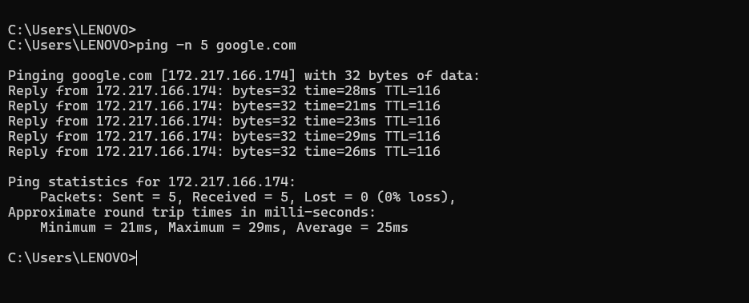

* ping –a google.com

* ping -I TTL google.com



* ping -l size

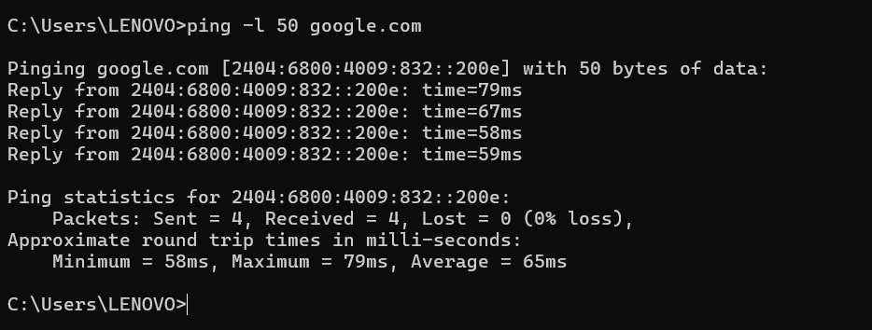

## getmac

### Description:

The getmac command is a Windows command-line utility that displays the Media Access Control (MAC) addresses for the network interfaces on a system. It can be used to retrieve the physical address (MAC address) of all network adapters, whether they are active or inactive.

|  |  |  |
| --- | --- | --- |
| No. | Option | Description |
| 1 | getmac /fo csv | Specifies the format in which the output is to be displayed.  Valid values: “TABLE”,“LIST”,“CSV” |
| 2 | getmac /v | Specifies that verbose output is displayed. |
| 3 | getmac /nh | Resolve addresses to hostnames. |
| 4 | getmac /s system | Specifies the remote system to connect to. |
| 5 | Getmac /u | Specifies the user context under which the command should execute |

### Implementation:

* getmac /fo csv1

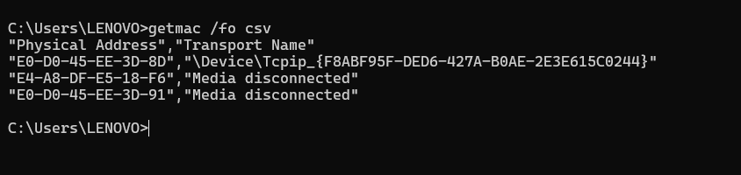

* getmac /v

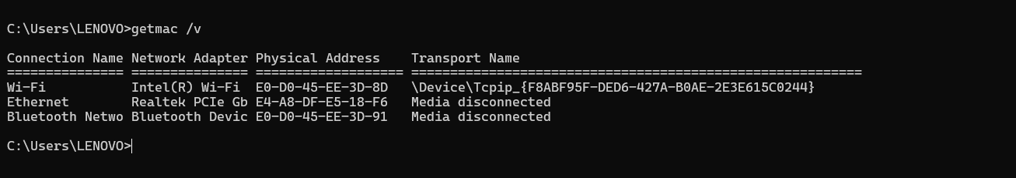

* getmac /nh

* getmac /s

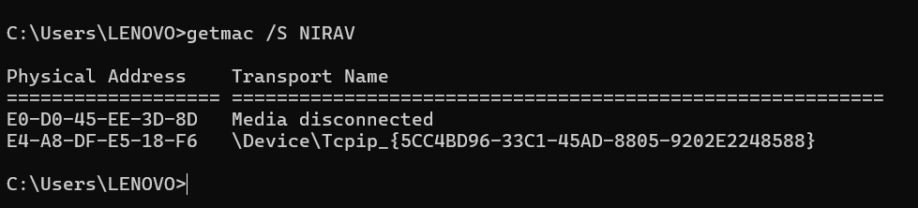

* getmac /u

## systeminfo

### Description:

The ‘systeminfo’ command is a command-line utility in Windows that provides detailed information about the system's hardware and software configuration. It displays information such as the operating system version, hardware details, network configuration, and other system properties.

|  |  |  |
| --- | --- | --- |
| No. | Option | Description |
| 1 | systeminfo /S | Specifies the remote system to connect to. |
| 2 | systeminfo /FO format | Specifies the user context under which the command should execute.  Valid values: "TABLE", "LIST", "CSV". |
| 3 | systeminfo /NH | Specifies that the "Column Header" should not be displayed in the output.  Valid only for TABLE and CSV formats. |
| 4 | systeminfo /P | Specifies the password for the given user context. Prompts for input if omitted. |
| 5 | systeminfo /U | Specifies the user context under which the command should execute. |

### Implementation:

* systeminfo /S

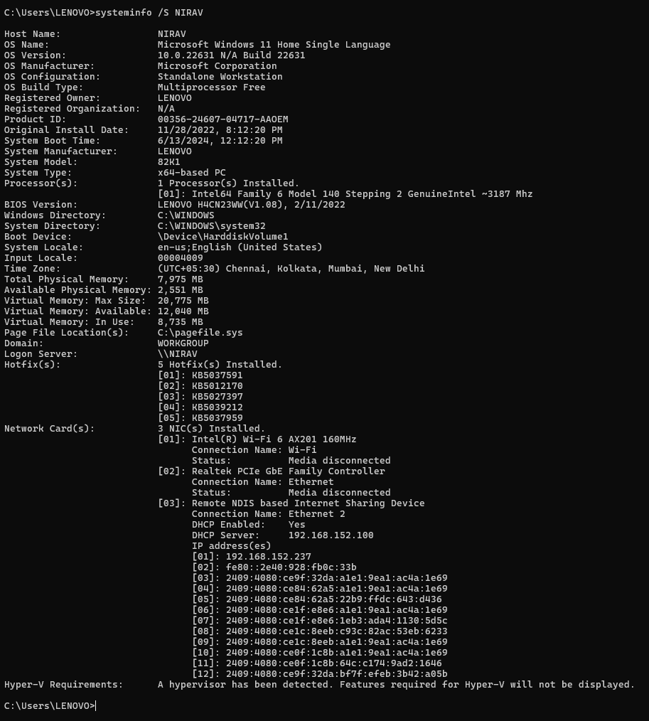

* systeminfo /FO format

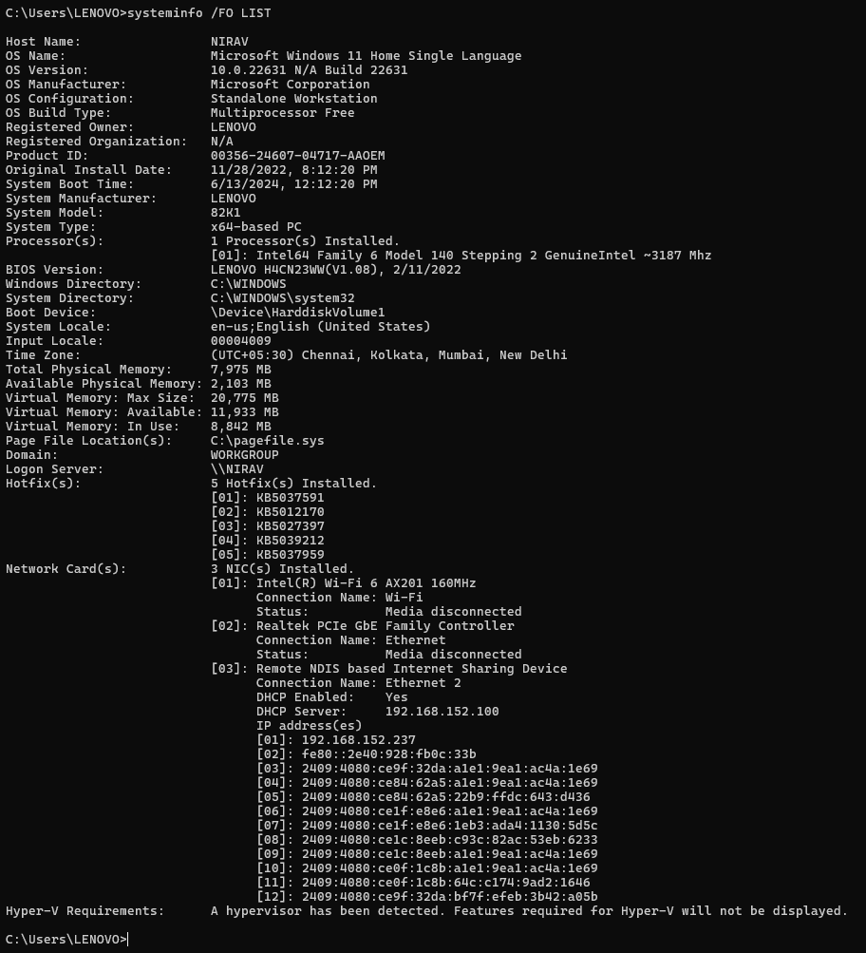

* systeminfo /U

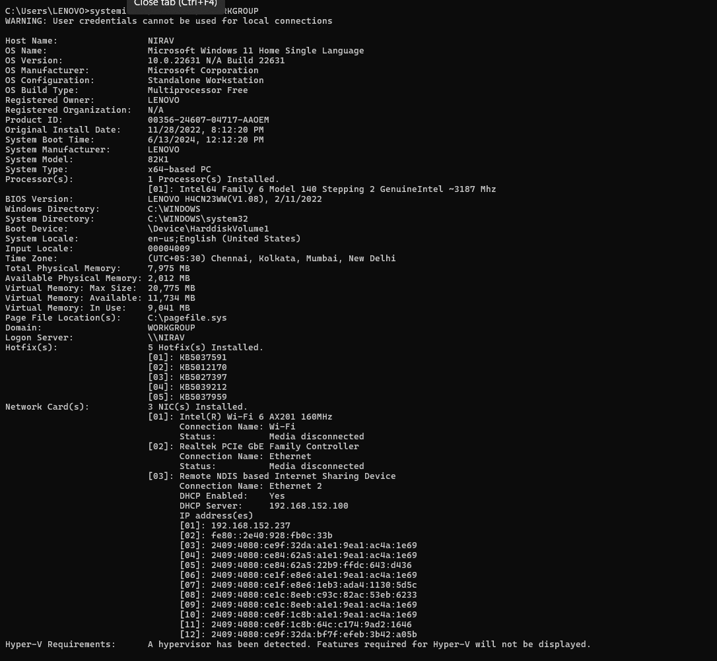

* systeminfo /NH

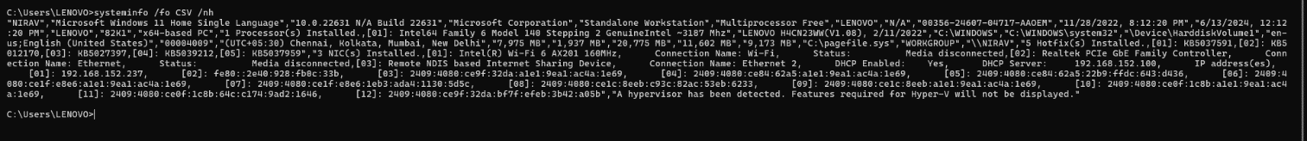

* systeminfo /P

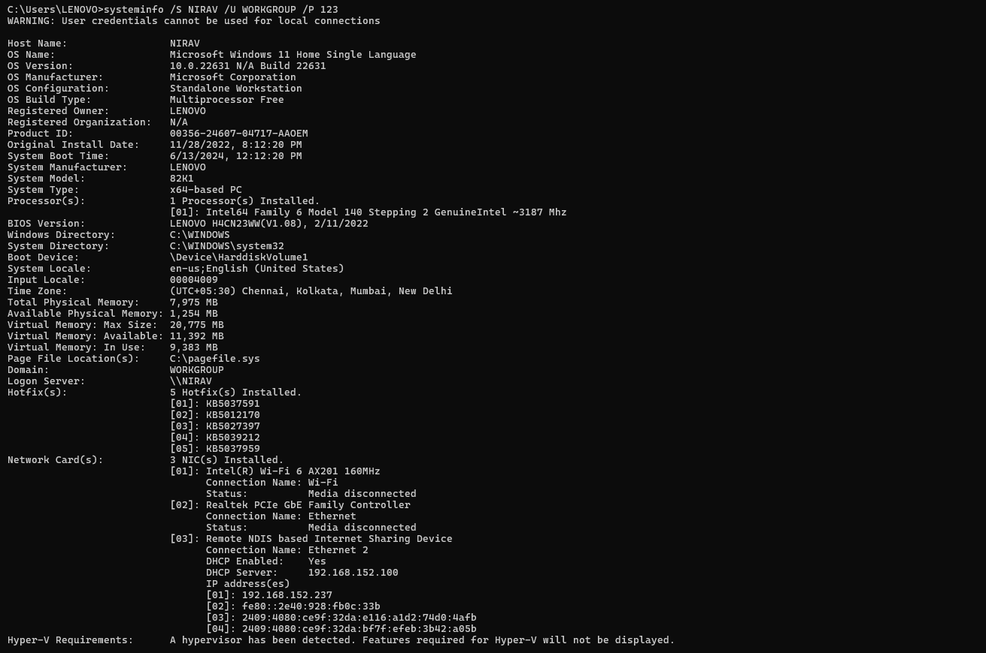

## tracert

### Description:

The ‘tracert’ (short for "trace route") command in Windows is a diagnostic tool used to track the path that packets take from your computer to a specified destination (like a website or IP address). It shows each hop along the route and the time it takes for each hop.

|  |  |  |
| --- | --- | --- |
| No. | Option | Description |
| 1 | tracert -d | Do not resolve addresses to hostnames. |
| 2 | tracert -h | Maximum number of hops to search for target. |
| 3 | tracert -w | Wait timeout milliseconds for each reply. |
| 4 | tracert -4 | Force using IPv4. |
| 5 | tracert -6 | Force using IPv6. |

### Implementation:

* tracert -d

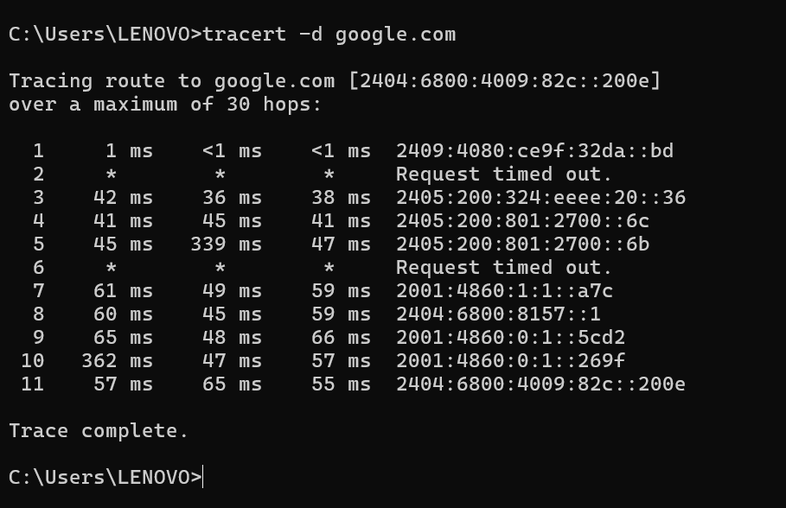

* tracert -h

* tracert -w

* tracert -4

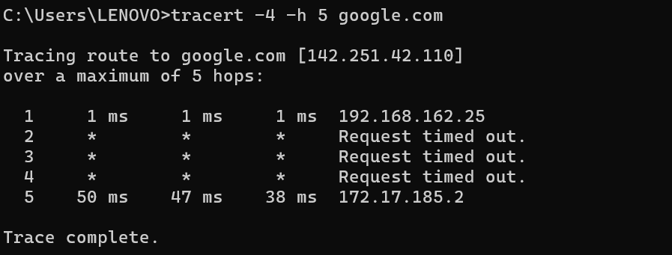

* tracert -6

## netstat

### Description:

The ‘netstat’ (network statistics) command is a powerful networking tool in Windows that displays various network connections, routing tables, interface statistics, masquerade connections, and multicast memberships. It's widely used for diagnosing network issues and monitoring network performance.

|  |  |  |
| --- | --- | --- |
| No. | Option | Description |
| 1 | netstat –a | Displays all connections and listening ports. |
| 2 | netstat –e | Displays Ethernet statistics. This may be combined with the –s option. |
| 3 | netstat –f | Displays Fully Qualified Domain Names (FQDN) for foreign addresses. |
| 4 | netstat –i | Displays the time spent by a TCP connection in its current state. |
| 05 | netstat -x | Displays NetworkDirect connections, listeners, and shared endpoints. |

### Implementation:

* netstat -a

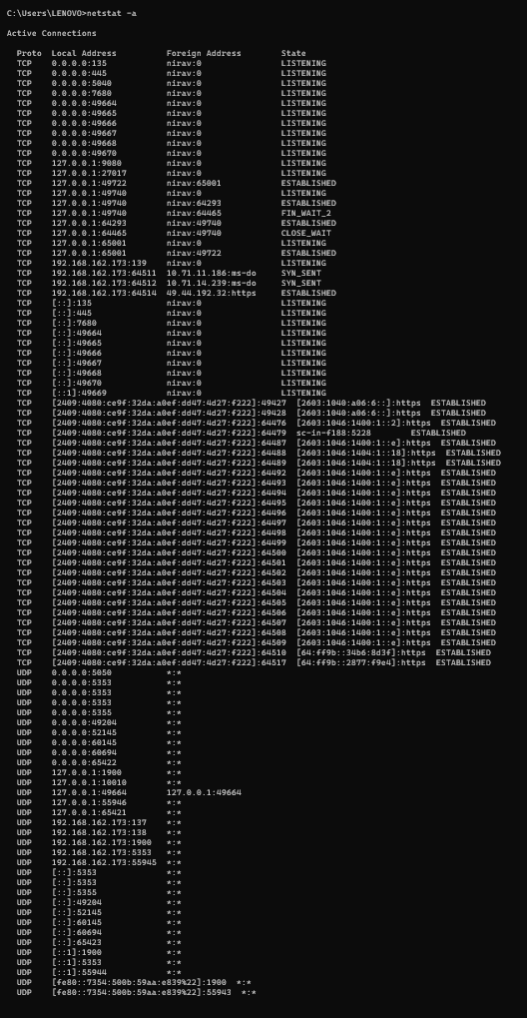

* netstat -e

* netstat -f

* netstat -i

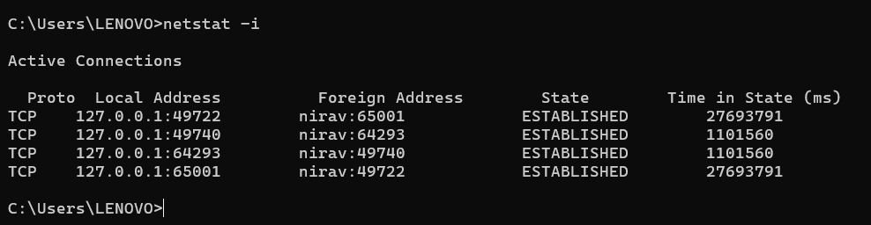

* netstat -x

## nslookup

### Description:

The ‘nslookup’ (name server lookup) command is a network administration command-line tool available in many computer operating systems for querying the Domain Name System (DNS) to obtain domain name or IP address mapping or for any other specific DNS record.

|  |  |  |
| --- | --- | --- |
| No. | Option | Description |
| 1 | nslookup | Displays information that you can use to diagnose Domain Name System infrastructure |
| 2 | nslookup is | Lists information for a DNS domain |
| 3 | nslookup finger | Connects with the finger server on the current computer. |
| 4 | nslookup -port | Specify a different port. |
| 5 | nslookup -timeout | Set timeout for a reply. |

### Implementation:

* nslookup

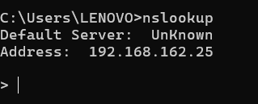

* nslookup is

* nslookup finger

* nslookup -port

* nslookup -timeout

## hostname

### Description:

The ‘hostname’ command in Windows displays the name of the current host, which is typically the computer name.

|  |  |  |
| --- | --- | --- |
| No. | Option | Description |
| 1 | hostname –a | Displays all connections and listening ports. |
| 2 | hostname –e | Displays Ethernet statistics. This may be combined with the –s option. |

### Implementation:

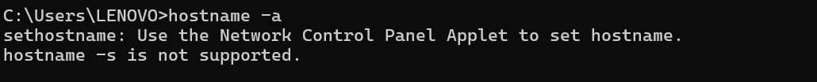

## pathping

### Description:

The ‘pathping’ command is a network diagnostic tool available in Windows that combines the functionality of ‘ping’ and ‘tracert’. It provides information about network latency and packet loss along the path between the local computer and a specified destination, similar to ‘tracert’, while also measuring the round-trip time of each hop, similar to ping.

|  |  |  |
| --- | --- | --- |
| No. | Option | Description |
| 1 | pathping –4 | Force using IPv4. |
| 2 | pathping –g | Loose source route along host-list. |
| 3 | pathping –n | Do not resolve addresses to hostnames. |
| 4 | pathping –q | Number of queries per hop. |
| 5 | pathping -w | Wait timeout milliseconds for each reply. |

### Implementation:

* pathping -4

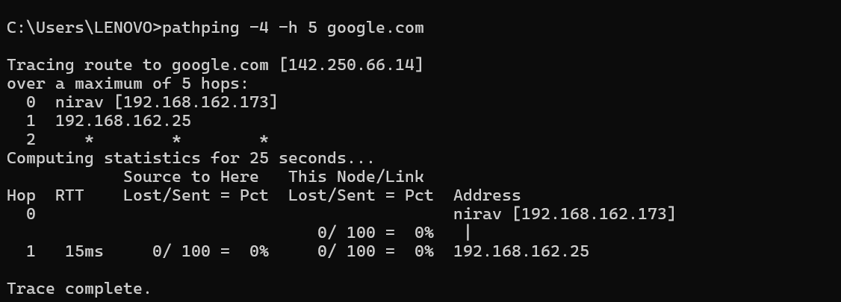

* pathping -g

* pathping -n

* pathping -q

* pathping -w

### Description:

The ‘arp’ (Address Resolution Protocol) command in Windows displays and modifies the local Address Resolution Protocol (ARP) cache, which maps IP addresses to physical MAC (Media Access Control) addresses on a local network.

|  |  |  |
| --- | --- | --- |
| No. | Option | Description |
| 1 | arp –a | Display ARP Cache for All Interfaces |
| 2 | arp -g | Displays the ARP cache for a specific interface. |
| 3 | arp /? | Display and modify the enteris in the address  resolution protocol. |

### Implementation:

* arp -a

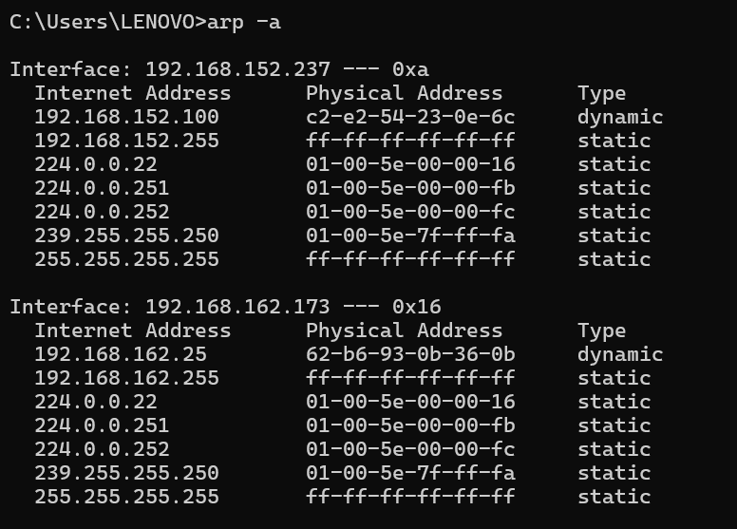

* arp -g

* arp /?

